**11**- **EXCEPTION HANDLING**

**Ex. No. : 11.1 Date: 02.06.24**

**Register No.: 231901055 Name: Tharun H**

**EXCEPTION HANDLING**

To find whether a digit lies in the specified range(1-100). Handling exceptions for invalid inputs and out-of-range numbers .

Input Format:

User inputs a number.

Output Format:

Confirm the input or print an error message if it's invalid or out of range.

**For example:**

| **Input** | **Result** |
| --- | --- |
| 1 | Valid input. |
| 101 | Error: Number out of allowed range |
| rec | Error: invalid literal for int() |

**Program:**

try:

a=input()

if(int(a)>0 and int(a)<101):

print("Valid input.")

else:

print("Error: Number out of allowed range")

except:

print("Error: invalid literal for int()")

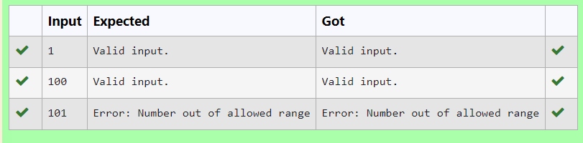

**Ex. No. : 11.2 Date: 02.06.24**

**Register No.: 231901055 Name Tharun H**

**EXCEPTION HANDLING**

Write a Python program that performs division and modulo operations on two numbers provided by the user. Handle division by zero and non-numeric inputs.

Input Format:

Two lines of input, each containing a number.

Output Format:

Print the result of division and modulo operation, or an error message if an exception occurs.

**For example:**

| **Input** | **Result** |
| --- | --- |
| 10  2 | Division result: 5.0  Modulo result: 0 |
| 7  3 | Division result: 2.3333333333333335  Modulo result: 1 |
| 8  0 | Error: Cannot divide or modulo by zero. |

**Program:**

try:

a=input()

b=input()

c=int(a)/int(b)

d=int(a)%int(b)

except ZeroDivisionError:

print("Error: Cannot divide or modulo by zero.")

except:

print("Error: Non-numeric input provided.")

else:

print("Division result:",c)

print("Modulo result:",d)

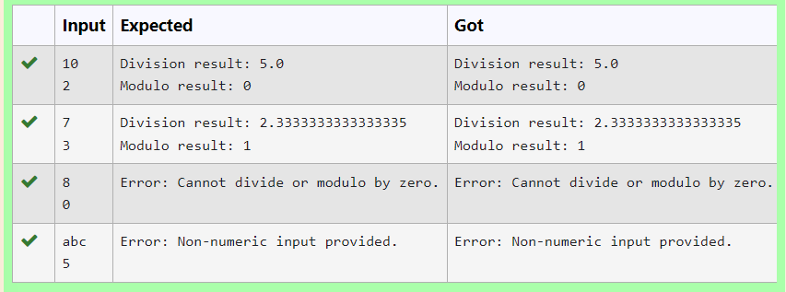

**Ex. No. : 11.3 Date: 02.06.24**

**Register No.: 231901055 Name: Tharun H**

**EXCEPTION HANDLING**

Write a Python program that asks the user for their age and prints a message based on the age. Ensure that the program handles cases where the input is not a valid integer.

**Input Format:** A single line input representing the user's age.

**Output Format:** Print a message based on the age or an error if the input is invalid.

**For example:**

| **Input** | **Result** |
| --- | --- |
| twenty | Error: Please enter a valid age. |
| 25 | You are 25 years old. |
| -1 | Error: Please enter a valid age. |

**Program:**

try:

a=input()

if int(a)>=0:

print("You are",a,"years old.")

else:

print("Error: Please enter a valid age.")

except:

print("Error: Please enter a valid age.")

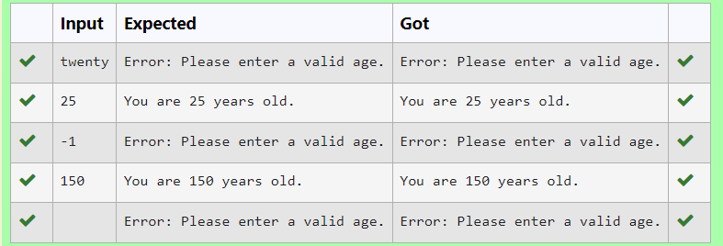

**Ex. No. : 11.4 Date: 02.06.24**

**Register No.: 231901055 Name: Tharun H**

**EXCEPTION HANDLING**

Develop a Python program that safely calculates the square root of a number provided by the user. Handle exceptions for negative inputs and non-numeric inputs.

Input Format:

User inputs a number.

Output Format:

Print the square root of the number or an error message if an exception occurs.

**For example:**

| **Input** | **Result** |
| --- | --- |
| 16 | The square root of 16.0 is 4.00 |
| -4 | Error: Cannot calculate the square root of a negative number. |
| rec | Error: could not convert string to float |

**Program:**

import math

try:

n=input()

n=float(n)

if n < 0:

print("Error: Cannot calculate the square root of a negative number.")

else:

r= math.sqrt(n)

print("The square root of {} is {:.2f}".format(n, r))

except ValueError:

print("Error: could not convert string to float")

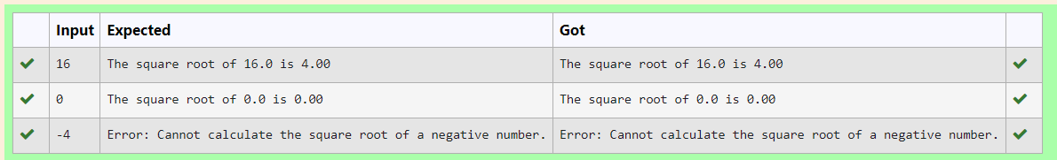

**Ex. No. : 11.5 Date: 02.06.24**

**Register No.: 231901055 Name: Tharun H**

**EXCEPTION HANDLING**

Develop a Python program that safely performs division between two numbers provided by the user. Handle exceptions like division by zero and non-numeric inputs.

**Input Format:** Two lines of input, each containing a number.

**Output Format:** Print the result of the division or an error message if an exception occurs.

**For example:**

| **Input** | **Result** |
| --- | --- |
| 10  2 | 5.0 |
| 10  0 | Error: Cannot divide or modulo by zero. |
| ten  5 | Error: Non-numeric input provided. |

**Program:**

try:

a=input()

b=input()

c=float(a)/float(b)

except ZeroDivisionError:

print("Error: Cannot divide or modulo by zero.")

except:

print("Error: Non-numeric input provided.")

else:

print(c)

